

**Flutter Assignments Software EngineeringAssignment**

**MODULE: 2**

**SE – HTML and CSS**

**1.Define the terms: Website, Webpage, Web browser, Web server,**

**HTML,CSS**

**1.website**

A website is a collection of web pages and related content. a place connected to the Internet, where a company, organization, etc. puts information that can be found on the World Wide Web

example : www.amazon.in

it is e-commerce website for shopping.

**2.Webpage**

A web page is a document on the World Wide Web "with its own address".A Web page is a document for the World Wide Web that is identified by a unique uniform resource locator (URL). A Web page can be accessed and displayed on a monitor or mobile device through a Web browser .

example :<https://www.w3schools.com/html/>

**3.Web Browser**

A web browser is an application for accessing websites and the Internet. When a user requests some information, the web browser fetches the data from a web server and then displays the webpage on the user's screen.

example : google chrome

**4.Web Server**

A web server is computer software and underlying hardware that accepts requests via HTTP or its secure variant HTTPS.

A web server is a computer system capable of delivering web content to end users over the internet via a web browser.

**5.HTML**

The HyperText Markup Language or HTML is the standard markup language for documents designed to be displayed in a web browser. It defines the content and structure of web content.

HTML describes the structure of a Web page.

**6.CSS**

Cascading Style Sheets is a style sheet language used for specifying the presentation and styling of a document written in a markup language such as HTML or XML. CSS is a cornerstone technology of the World Wide Web, alongside HTML and JavaScript.

**2. Create a webpage to show “This is my first HTML page”**

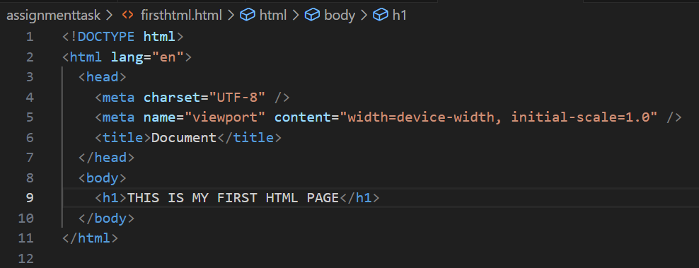

**Output:**

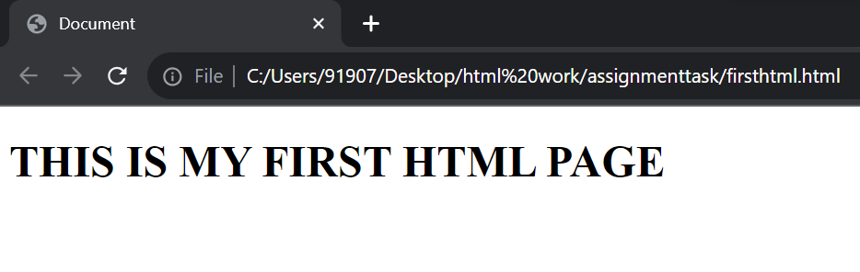

**3. Display top 10 IT companies list in html webpage.**

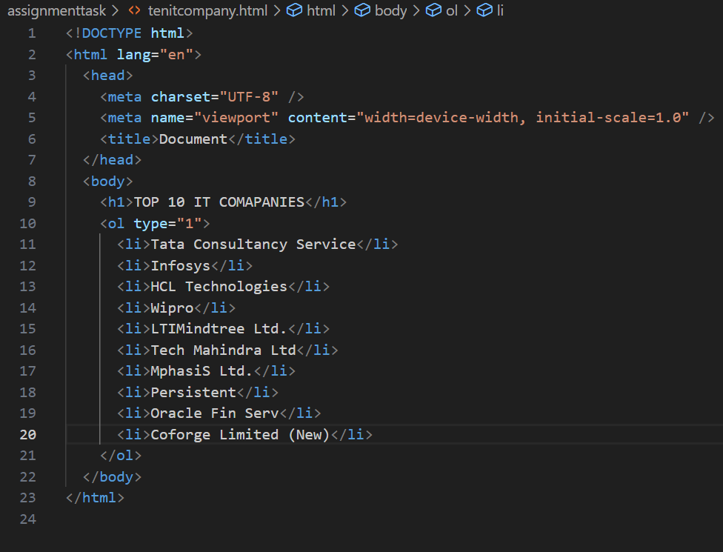

**Output:**

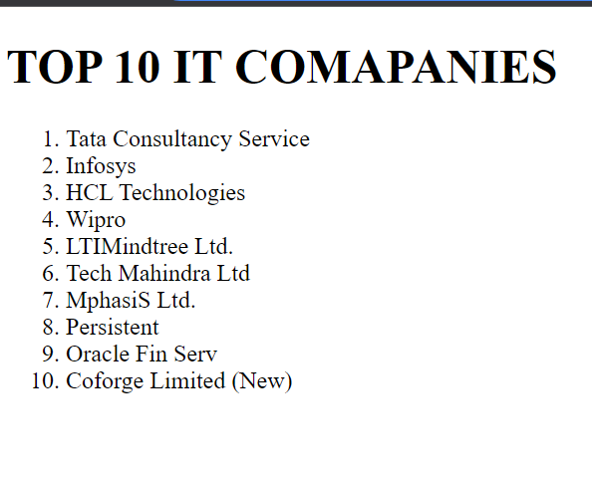

**4. Create a dropdown list.**

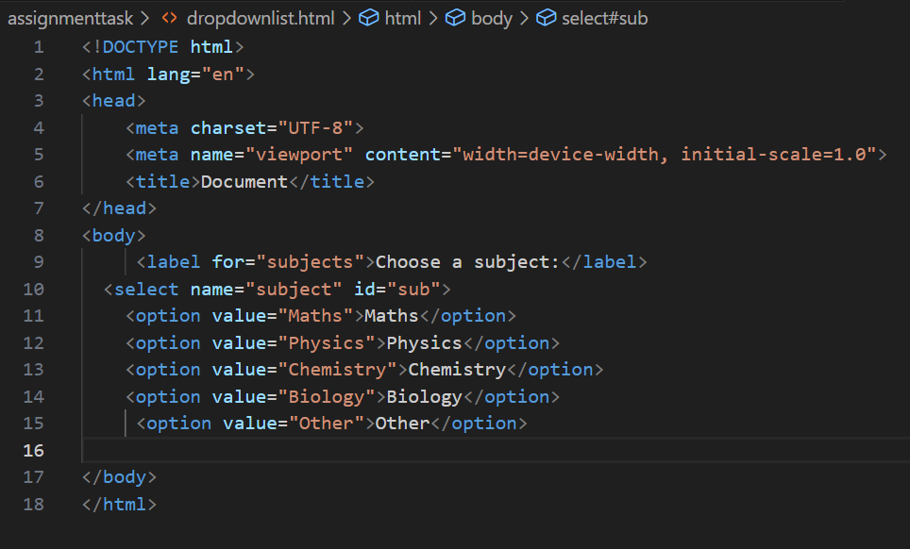

**Output:**

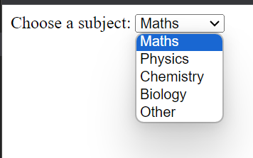

**5.** **Create a Table Of college Management system using row span & colspan.**

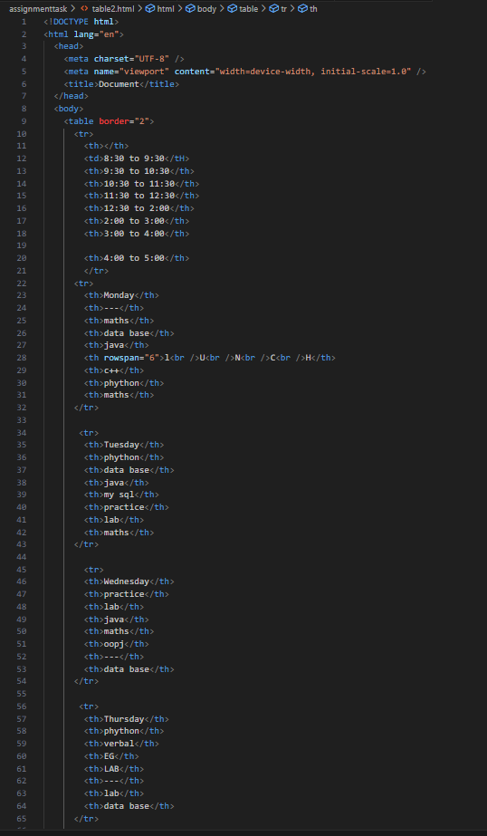

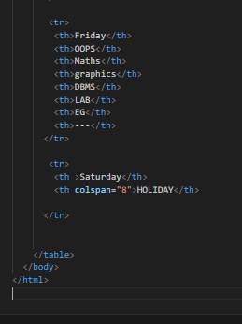

**Output:**

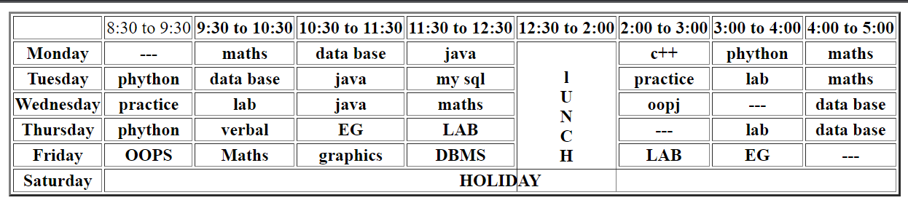

**6. Create below table using HTML table tags.**

**1.**

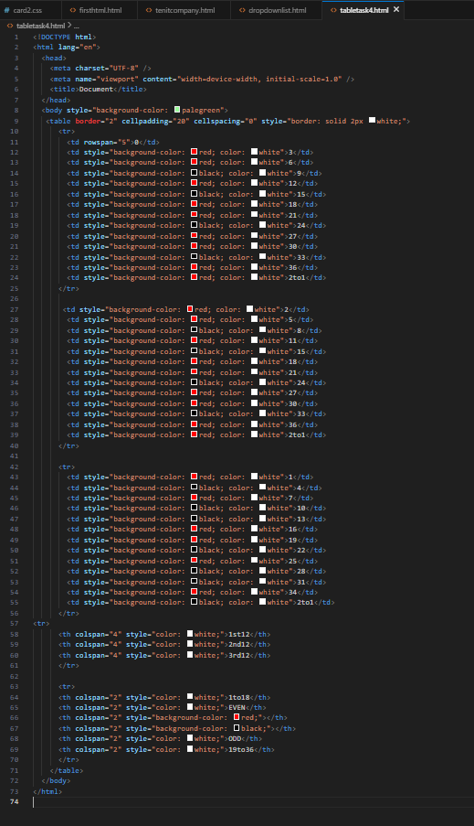

**Output:**

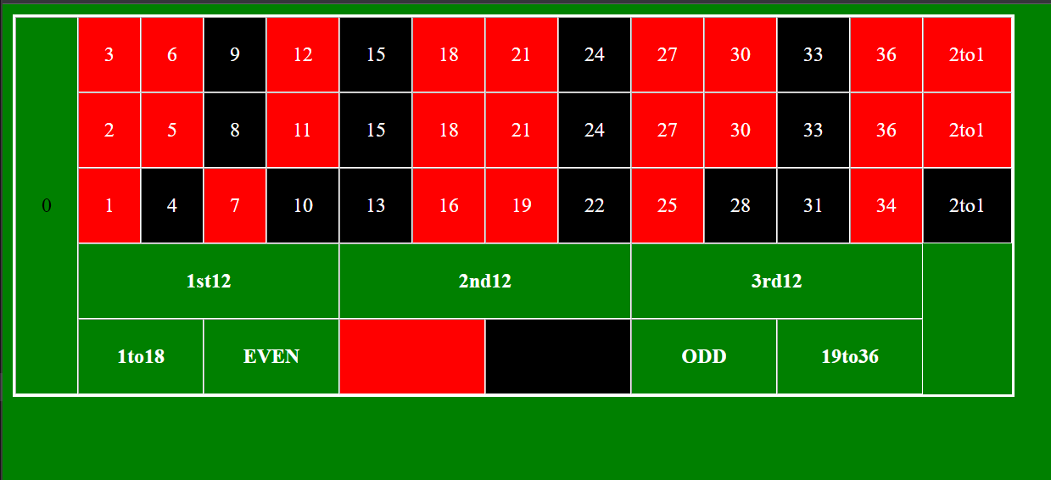

**2**

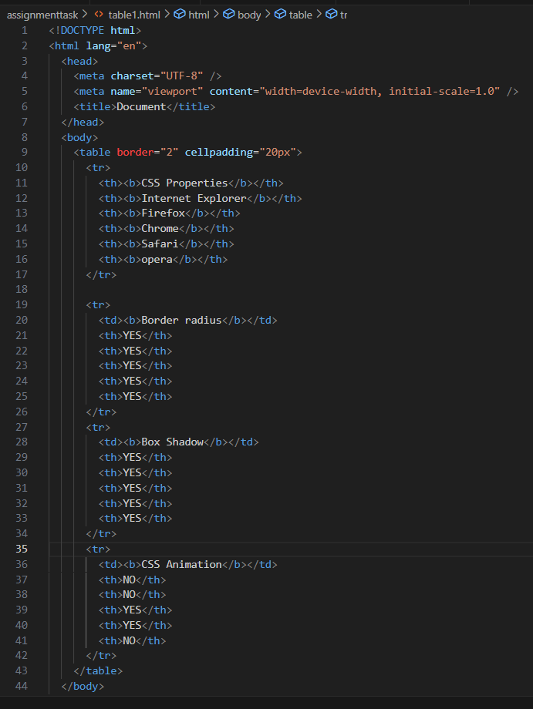

**Output:**

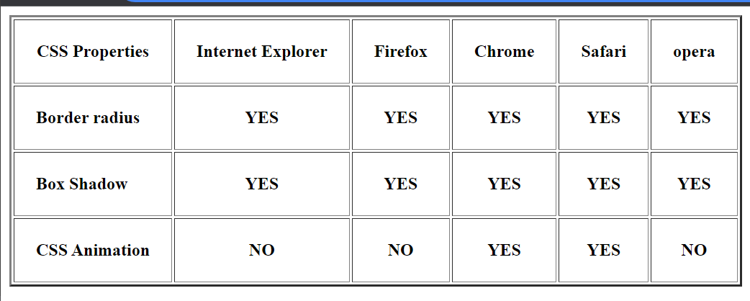

**7. Create Registration form using HTML, CSS.**

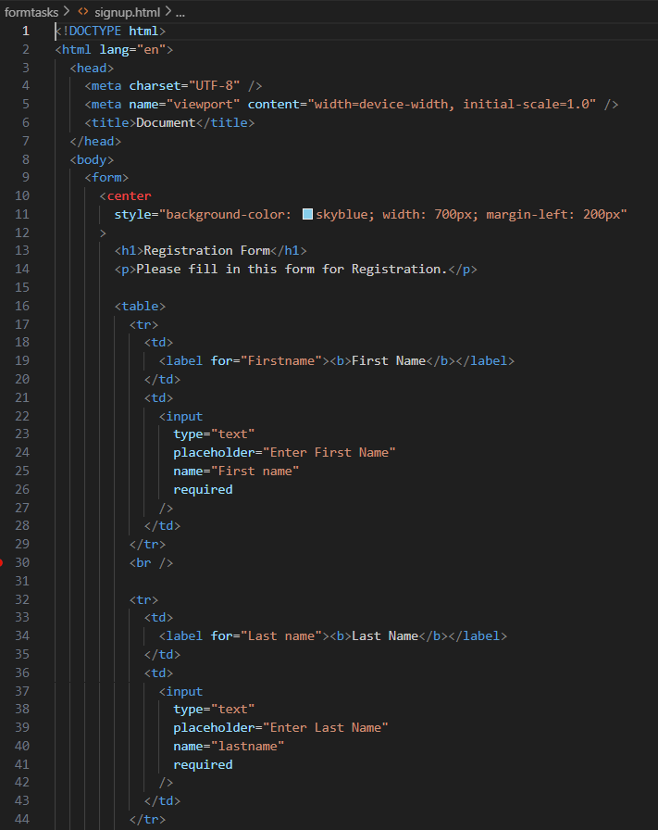

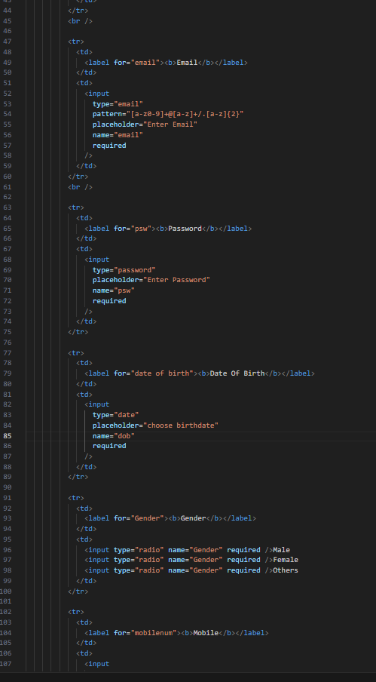

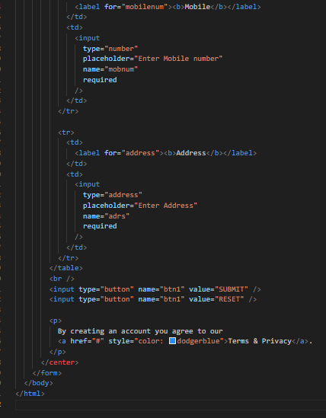

**Output:**

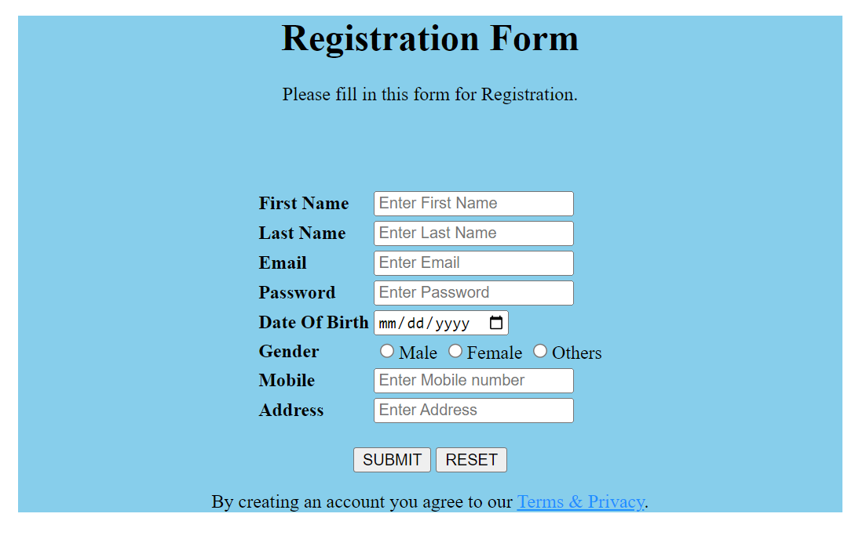

**8.In how many ways can a CSS be integrated as a web page?**

ans: there are three ways to integrate CSS into Web page

1.inline - by using the style attribute inside HTML elements.

2.Internal - by using a <style> element in the <head> section.

3.External - by using a <link> element to link to an external CSS file.

**9. Create simple three pages using External CSS, Internal CSS, and Inline CSS.**

**1.inline css**

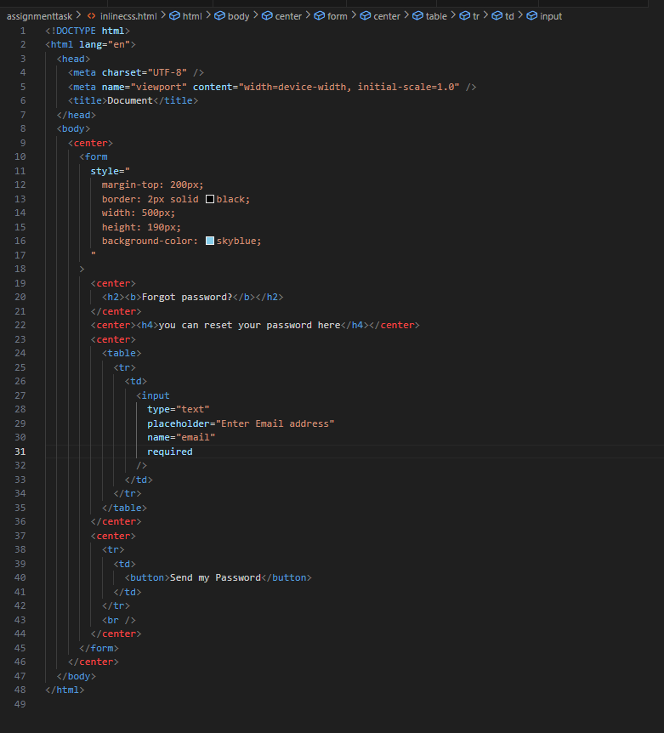

**Output:**

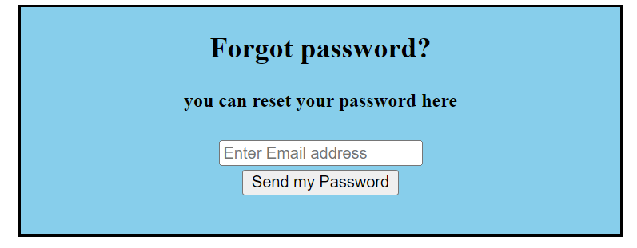

**2.internal css:**

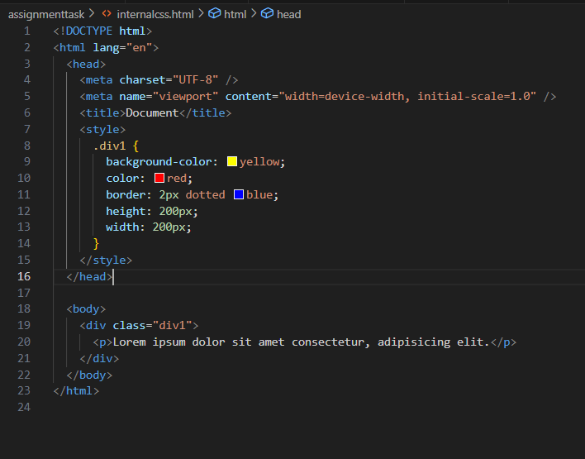

**Output:**

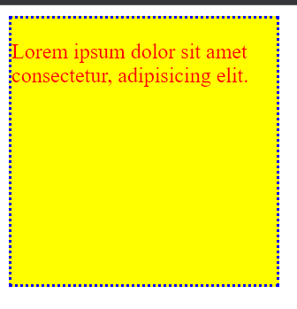

**3.exterrnal css:**

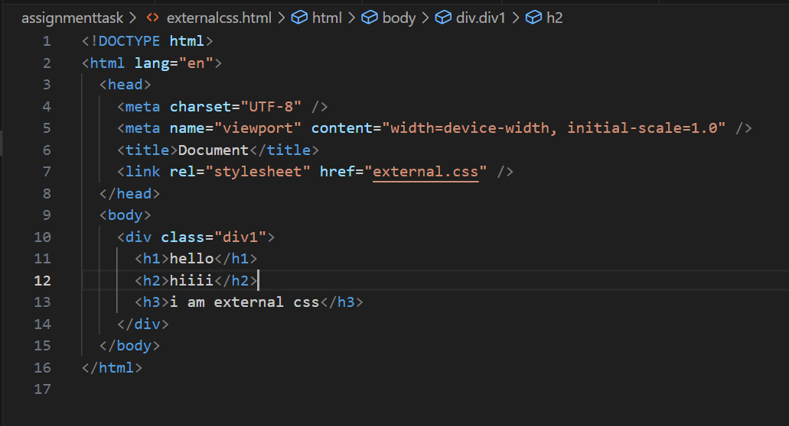

**Output:**

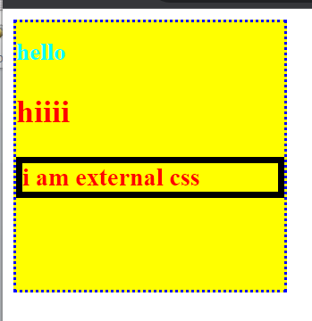

**10.Create below page using HTML CSS.**

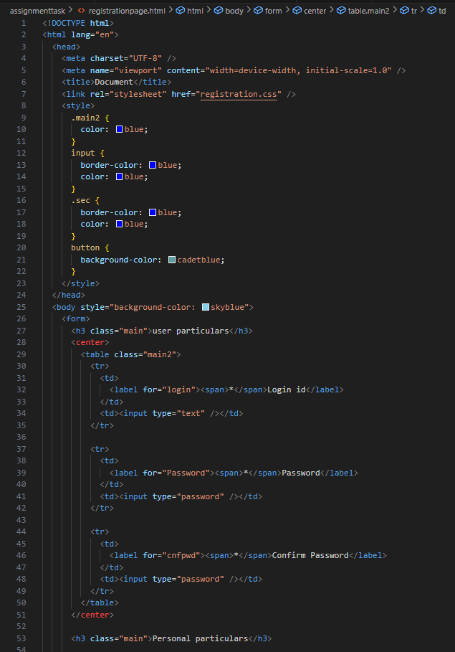

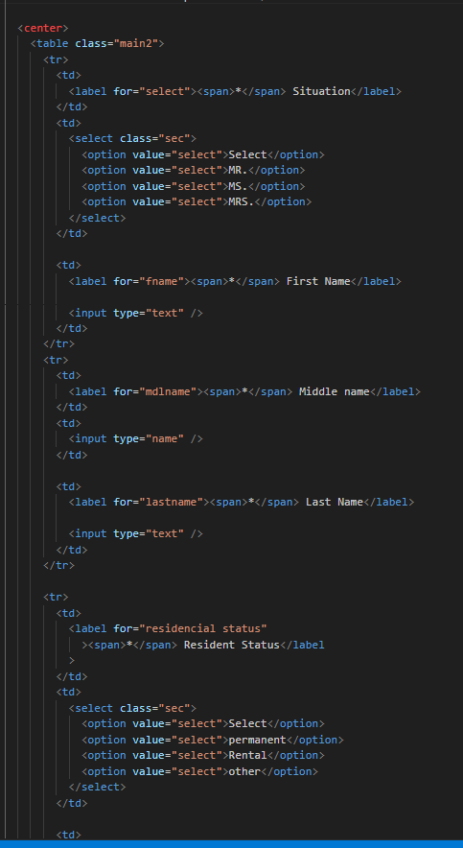

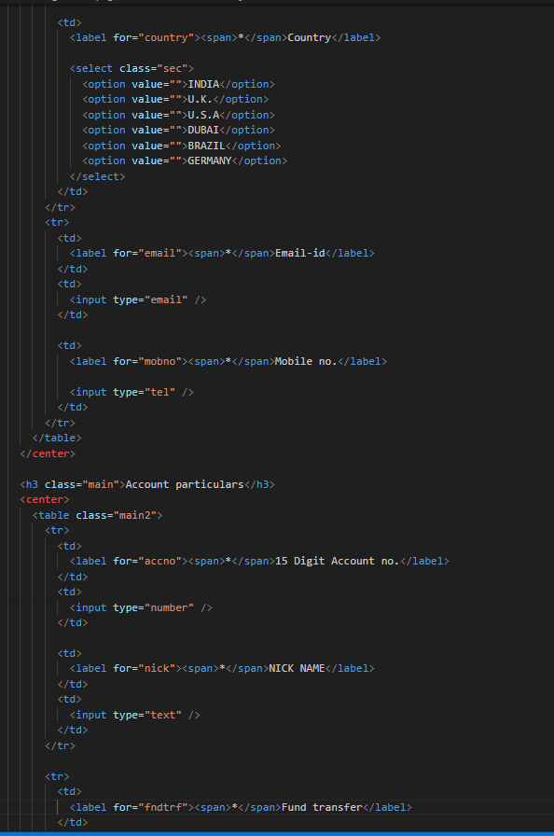

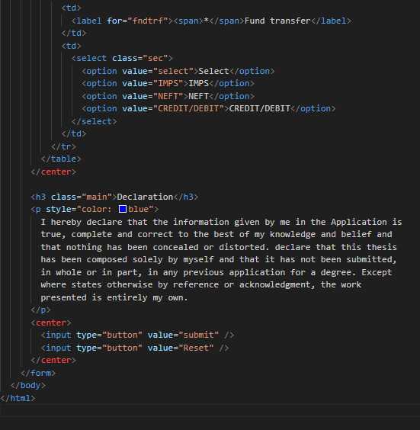

**Output:**

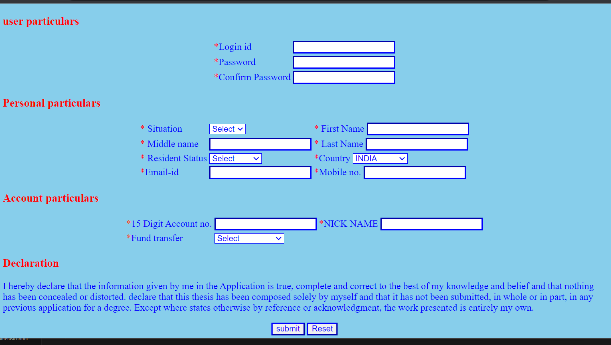

**11. Create link-pseudo classes using external css,to format links on the pages.**

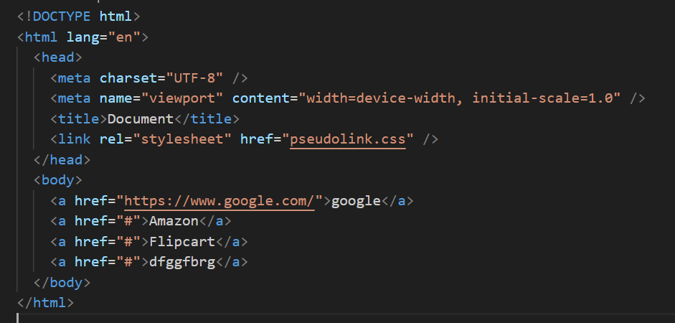

**Output:**



**12. Create a dynamic pseudo class using HTML, CSS.**

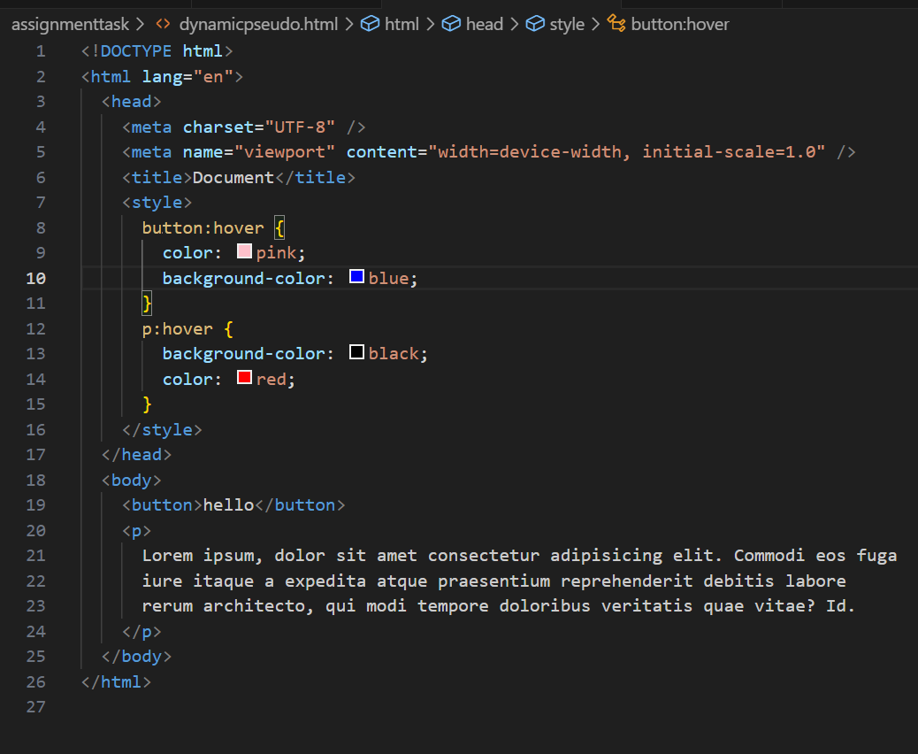

**Output:**

